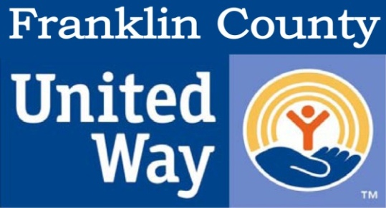
DAY OF CARING
SATURDAY OCTOBER 22, 2016

Do You Need Help or Know Someone Who Does?
We can help with projects that include yard work, painting, basic repair, house cleaning, handicapped ramps or simple porch repairs

Note: We cannot help with electrical, plumbing or structural repairs

Please visit www.UWFC.org to print a project application

Also visit www.UWFC.org to volunteer.
You can make a difference!

Completed application due on or before October 14, 2016
United Way of Franklin County
P.O. Box 342, Louisburg, NC 27549
(919) 495-9179 ♦ uwfcdirector@embarqmail.com ♦ www.uwfc.org

